➢ **After Logging In**

**(Everything in this Document is line wise, so go by page to page heading to heading wisely)**

# Page: Desktop1

**(Same changes as the Before Login, Except:**

1. Here at the “Professionels” button replace it with “My Account or My Profile” button and make it a “One” Button for Profile not two like in below picture.

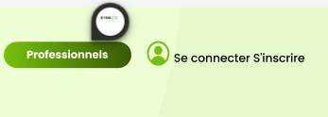

1. Replace the “B to B Job Pro” Logo with the simple one not the “Pro”.



**(Rest Changes will be followed by the previous “Before Login Pages” Document)**

# Page: Profile View

1. Translate the below “Picture given” text to:

Regular > Régulier

Premium > Prime

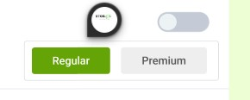

1. Replace the blow Picture given text with: “Quoi de neuf ?”

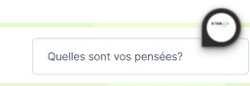

1. Replace the below Picture given text with: “envoie”

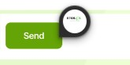

1. Delete this specific field from this page:



# Page: Professional Rate

**1.** Translate this page … whenever the professionals upload or update their rates on their profile.

Daily > Tous les jours

Day > Jour

Days > Jours

OR > OU

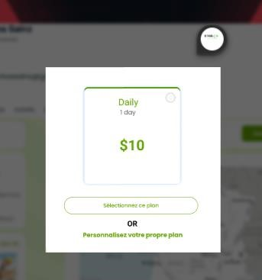

# Page: Professional Rate -2

**1.** Translate this page:

Set your Rate > Définissez votre tarif

Time > Temps

Cancel > Annuler

Save > Sauvegarder

Price Range > Échelle des prix

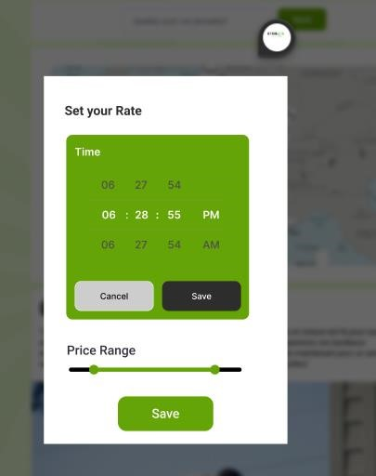

# Page: Offers Page

1. Replace the text with “Accueil”

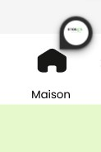

1. Replace the text offres with offre



1. Add a clickable button and icon “Forum” just on the right side of the “Messagerie”

Button (in the header section)

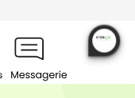

1. Replace the below picture text with “Engager un pro”

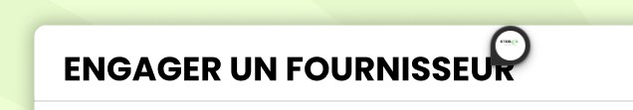

# Page: Post a Private Request

**1.** Translate the below picture’s text:

You Have 25+ Total Category > Nous avons plus de 25 catégories au total



# Page: Post a Private Request - 2

**1.** Translate the below Picture’s text:

Select Category > Choisir une catégorie



# Page: Post a Private Request - 3

**1.** Add a text in the below picture mentioned area:

**TEXT TO BE ADDED:**

Demande Envoyée

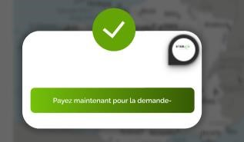

**Page: All Themes**

**+**

**Page: All Themes-2**

**+**

**Page: All Themes-Rent**

**+**

# Page: All Themes-Adding a Rent Item

**(WHEN WE CLICK ON “ALL THEMES” – DIFFERENT TYPES OF THEMES APPEAR LIKE:**

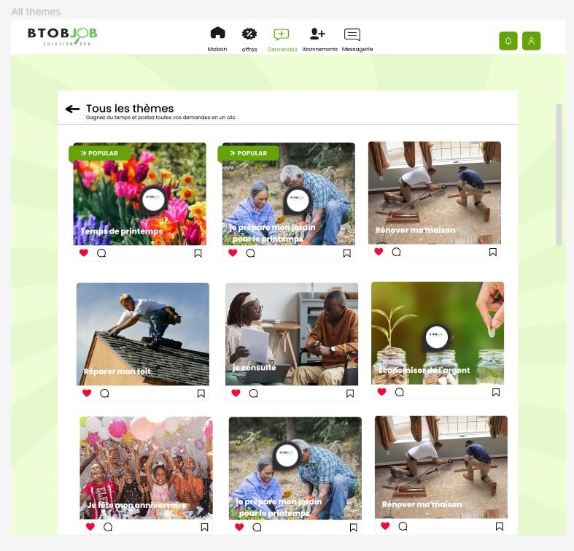

**– UNDER THOSE THEMES (AFTER CLICKING ON A SPECIFIC THEME),**

**LIKE:**



**THERE WILL BE A PAGE THAT WILL OPEN WITH 2 HEADINGS, LIKE:**

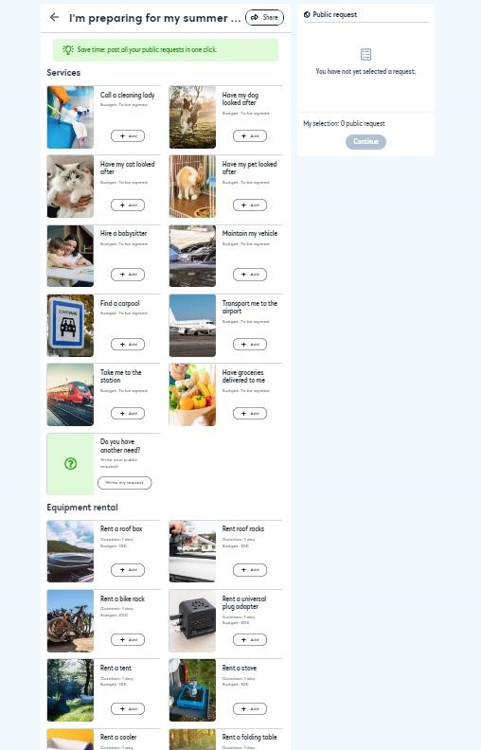

1. Services

**(UNDER SERVICES THERE WILL BE SERVICES THAT WILL BE OFFERED –**

**USERS CAN POST REQUEST OF THAT SPECIFIC SERVICE ON THE WEBSITE)**

1. Location d'équipement

**(EQUIPMENT THAT WILL BE RENTED BY THE USERS – USERS WILL DO THE**

**SAME AS SERVICES, POST REQUEST FOR THAT SPECIFIC EQUIPMENT ON THE WEBSITE)**

**Note: Every Theme will be having its specific (related) services and equipment.**

**For Example:**

**If someone click on a Theme “I am preparing for my Spring Break”**

**The Theme will open with 2 Headings:**

**1. Services:**

* Hire a Gardener
* Mow Your Garden

**2. Location d'équipement**

* Rent a Lawn Mower
* Rent a Showel

**PS:** Translate Rent and Day where ever it appears:

Rent > Louer

Day > Jour

# Page: Request

1. Replace the below picture’s whole text with “offres et demandes”



1. Delete the following section from this page:

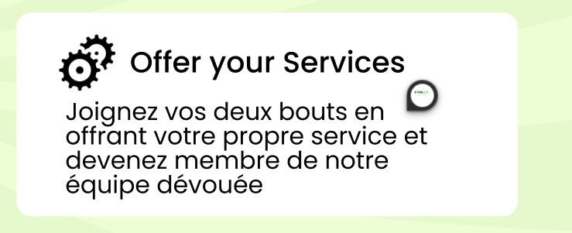

1. Delete the following button too from this page:



# Page: My Public Request

**1.** Replace the following text with “Demande” only



# Page: Add Address

**1.** Replace the following picture’s text phrase with “ajouter une adresse”



# Page: Messaging

1. Translate the below picture’s text with “Rechercher des messages”



1. Translate the days in messages:

Today > Aujourd'hui

Tomorrow > Demain

Yesterday > Hier

Day > Jour

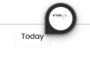

# Page: Messaging-2

**1.** Translate the below picture’s text with “Rechercher des messages”

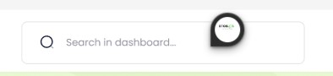

**(AND OTHER TRANSNLATIONS RELATED TO THAT PAGE)**

# Page: Payment Method

**Note: Only Transactions related to (if) anyone buy Subscription or any Website listed on and from (B to B Job) Website. Only Those Transactions will take place on the website. Rest, all other transactions related to Services and Offers will not take place on the Website.**

# Page: Profile View Drop-Down

1. Translate the below picture’s text: See my Profile > Voir mon profil



1. Delete the below mentioned both Buttons from Profile Drop-Down Menu:

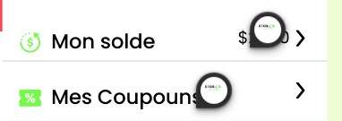

1. Change the below text phrase to:

Invitez un etre cher > invité un pro

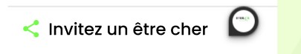

1. Delete the below mentioned button from Profile View Drop-Down:

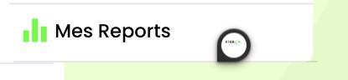

1. Translate the below text:

What are your thoughts? > Quelles sont vos pensées?

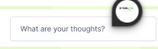

1. Translate the below text:

See all > Voir tout



1. Delete below mentioned text-phrase from this page:



1. Replace “comme” with “j'aime”

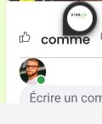

1. Translate the following text to “Partager”

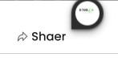

# Page: Balance

**1.** Delete the below Picture mentioned and marked title and Balance Info.

(Replace the the title “Equilbre” with “Votre Carte”).

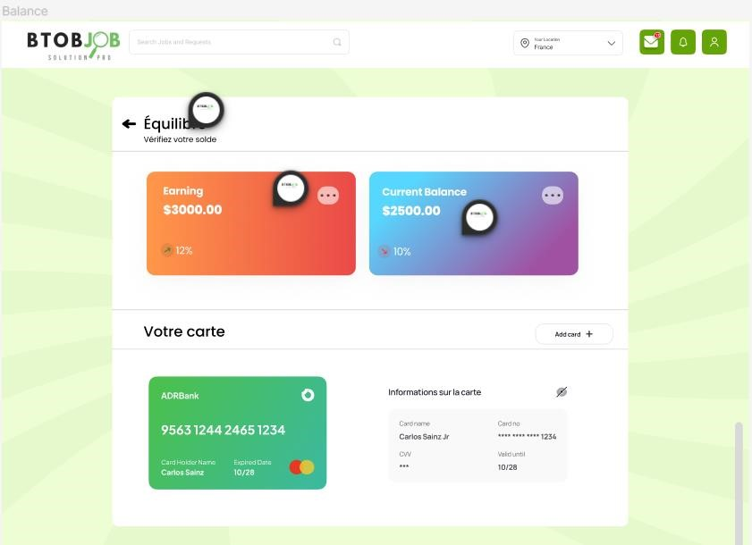

# Page: Coupons

**(Delete the Coupons Page Fully)**

# Page: User Profile Edit

**1.** Translate the following picture’s “passworde” to: “mot de passe”



**2.** Replace the “State” option in the User Profile Edit options from “State” to “Postal Code”, French Translation:  
Postal Code > Code Postal

# Page: Help

**1.** Delete the below picture’s mentioned button/function:

**2.** Delete the below picture’s mentioned button/function:

**3.** Translate the below picture’s mentioned English Phrase:

My Account > mon profil

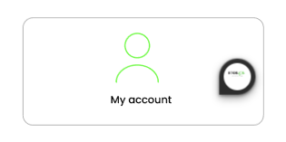

# Page: My Requests

**1.** Translate the below picture’s mentioned text-phrase:

Demande Publique > Demande

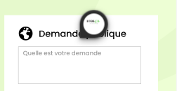

# Page: Verify Me

**(Delete this very page as the VERIFICATION is already done at the time of Registering (FOR PROFESSIONAL USERS ONLY)).**

# Page: Reports or My Reports

**(Delete this very page as the Client has suggested to Remove the Reports page button or option from the Profile Drop Down Menu too)**

# Page: Know Yourself Better

**(Delete this page too, as client suggested to do so).**

# Page: Service Requests

**(Do not Construct this specific page that is designed in the Figma Design as this page is extra and doesn’t need to be constructed, the main focus on what pages will be important for Service Requests are: Homepage, Offers Page, Themes Page)**

# Page: Buy Website

**1.** Replace the translation of this Header on this page by:

Translation: achetez votre site internet !



**2.** Replace the below picture’s mentioned area text by:

Translation: trouve le site qui te correspond



**3.** Remove the “Famous” and “Popular” Tags from the mentioned websites, as there is no actual need and it doesn’t makes sense whether a website be famous or popular after it is bought.



# Page: Posts Services

**1.** Replace the below picture’s mentioned text:

Des Stages > stages

**2.** Replace the below picture’s mentioned with:

Demanduer d’emploi > emplois

**3.** Replace the below picture’s mentioned text with:

Entrainement > Formation

# Page: Post of Job

**1.** Replace this Education option with Diploma “Yes” or “No” (Yes or No will be selected by the user themselves).



**2.** Translate the below picture’s mentioned text-phrase:

Share this job > Partager ce travail



# Page: Uploading CV

**1.** Translate the following picture mentioned text-phrases (MANY):

**TEXT-PHRASE (IN ENGLISH):**

Upload

Drag & drop files or Browse

Supported formates: JPEG, PNG, GIF, MP4, PDF, PSD, AI, Word, PPT

Uploading

your-file-here.PDF

Uploaded

document-name.PDF

image-name-goes-here.png

document-name.PDF

image-name-goes-here.png

UPLOAD FILES

**TRANSLATION (IN FRENCH):**

Télécharger

Glisser-déposer des fichiers ou Parcourir

Formats pris en charge : JPEG, PNG, GIF, MP4, PDF, PSD, AI, Word, PPT

Téléchargement

votre-fichier-ici.PDF

Téléchargé

nom-du-document.PDF

le nom de l'image va ici.png

nom-du-document.PDF

le nom de l'image va ici.png

TÉLÉCHARGER DES FICHIERS

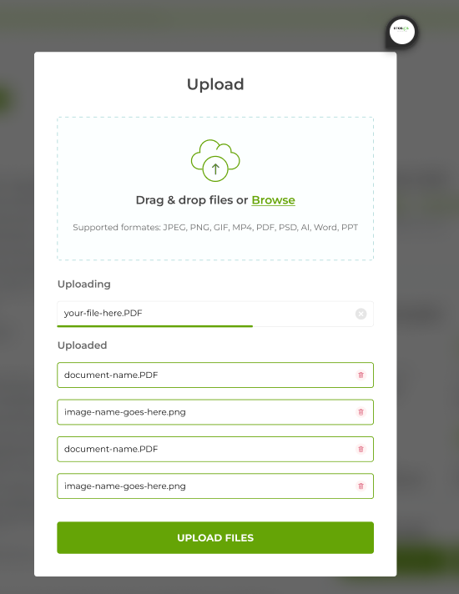

**-------------------------------------------------------------------------------------------------------------------------------------------------**

**PS: Also try to add a “Top 10 Pros of the Week” Heading under which the top 10 workers based on their recent reviews and rating will be shown.**

**Translation for “Top 10 Pros of the Week” > “top 10 des pros de la semaine”**

**Example:**

**-------------------------------------------------------------------------------------------------------------------------------------------------**

**PS: Correct the footer with the correct website link:  
Not b2bjob.com … but instead use this LINK:** btobjob.com

**-------------------------------------------------------------------------------------------------------------------------------------------------**

**PS: As the Client didn’t mentioned any Personal (Contact Us) Information for the Website, Replace that information by Nothing but “---“.**